O’Nancock St Patrick’s Parade and Festival
“Shamrock by Shamrock, Spring Begins”
Sunday, March 15 12 Noon to 5:00 pm
PARADE STAGING @1:00pm
Parade Entry Form
The 2020 theme for the parade is Shamrock by Shamrock, Spring Begins. We encourage you to incorporate the theme or your own variations for your parade decorations and your announcement. You may use your own as well.
Organization/Business: _________________________________________________________________
Contact Name: ________________________________________________________________________
Address: _____________________________________________________________________________
City: _____________________________________State: _________________Zip: _________________
Phone: ___________________ Email: _______________________________

Category (Please check all that apply):
 | Float (Truck/Tractor with trailer) |  | Equestrian (Indicate Number)  ____________________
 | Vehicle (Inclds cars, trucks, bicycles, tractors, motorcycles or scooters.) |  | Performance Group (Indicate Type)  ____________________
 | Walking Group (Indicate Number)  ____________________ |  | First Responder (Indicate Type)  ____________________

Length of ground space needed for line-up? __________feet
Brief Description of Entry (include # and types of vehicles, trailers, equipment, etc and # of paraders.): _______________________________________________________________________________________________________________________________________________________________________________________________________________________________________________________________
Will your entry produce sound levels that may spook live animals? Yes_____ No_____
Will you have live animals? Yes_____ No_____
*If yes, you must make provisions for clean-up crew for your entry.
Are there any special accommodations that your entry may need? Yes_____ No_____ _______________________________________________________________________________________________________________________________________________________________________________________________________________________________________________________________
PARADE ENTRY FORM CONTINUED

Do you want your entry to be judged? Yes _____ No _____
- See list of prize categories
Is your Entry also a festival participant? Yes _____ No _____
Are members of your group participating in the Kilt Contest? Yes _____ No _____
Entry Description--This is what the announcer will read when you are in front of the announcers stand. When lining up for the parade, PLEASE make sure your lineup order matches your vehicle listing on this form or your entry will be announced incorrectly.
___________________________________________________________________________________________________________________________________________________________________________________________________________________________________________________________________________________________________________________________________________________________________________________________________________________________________________________________________________________________________________________________________________________________________________________________________________________________________________________________________________________________________________________________________________________________________________________________________________________________________________________________________________________________________________________________________________________________________________________________________________________________________________________________________________________________________________________________________________________________________________________________________________________________________________________________________________________________________________________________

Signature: ______________________________________ Date: _________________

***PLEASE BE ADVISED THAT ALL ROUTINES THAT ARE PERFORMED ON MARKET ST AT THE INTERSECTION OF AMES STREET (AUDIENCE) AND AGAIN IF DESIRED AT THE TOWN SQUARE (JUDGES STAND) CANNOT EXCEED THREE (3) MINUTES***

RETURN FORM TO onancockparade@gmail.com.
Questions? Contact Bob Spoth at (703) 232 – 0258 or rspoth@eco-ins.com.
PARADE STAGING and PARADE INSTRUCTIONS:
Parade staging will be on College Ave. Please enter from Liberty Street. Please be there by 1:00 pm.
EXCEPT: Cars and Antique Tractors – There will be a car and antique tractor show at Ker Place. Please go straight there and we will insert you in the parade from there. Please also return there after the parade for the show. Please be there by 12:00 noon for the show.

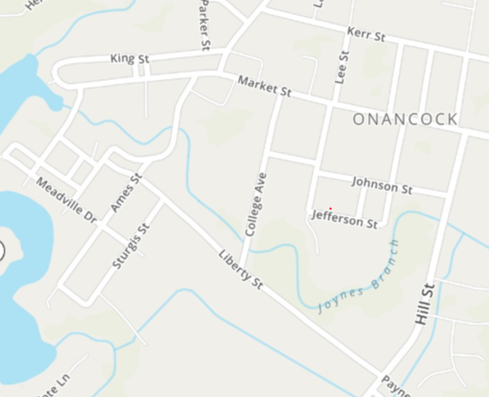

PARADE ROUTE AND EXIT:
Judges Table and Audience Parade Performances
Stage for Performances
Food Trucks and Other Vendors
Parade Announcer and Audience Performances

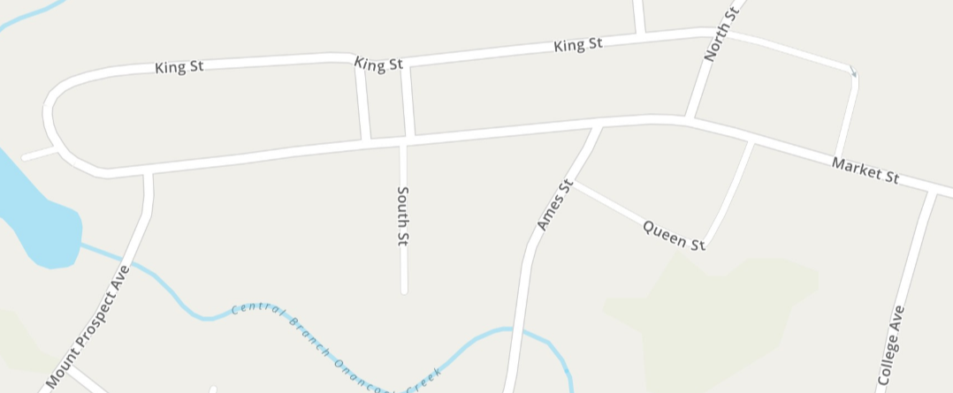
Parade Exit

North Street from King to Market will be closed for the block party.
Parade performances can be at Ames Street and/or at the judges stand.

Judged Contests:
- Best in Parade Judges Choice
- Best Animal Dogs, Horses
- Best Non-Motorized Walkers, Bicycles
- Best Motorized Cars, Golf Carts, Tractors (does not include floats)
- Best Float Floats
- Kilts
  - Traditional b. Creative c. First Responder

Weather: Pray for Good Weather! In the case that the parade has to be cancelled, we will post that by 11:00 am on the Facebook event page and the Onancock.com website.

