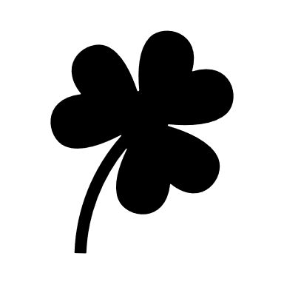
2020 O’Nancock St. Patrick’s Parade & Festival
KILT CONTESTANT ENTRY FORM
______________________________________________________________
Come strut your stuff at the annual kilt contest. This year’s contest will occur at the Town Square stage at 12:45.
KILT CONTEST
 | TRADITIONAL | Formal kilt attire
 | FIRST RESPONDER | Police, Fire, Ambulance, Medical Transport
 | NON-TRADITIONAL | His and hers? Plaid or fad? Team Spirit? Sparkles and spangles? Whatever makes you happy, just remember this is a family event.

CONTESTANT INFO
NAME
TELEPHONE
EMAIL
REPRESENTING*
* If representing a group, please indicate group.
Kilt contestants are invited to parade. Please indicate below if you intend to parade. Kilt contestants need not parade to participate in the contest, but are encouraged to do so. Staging for the parade occurs at 1:00 pm on College Avenue.
Yes. I wish to parade with the kilt contestants group.
Yes. I am parading with another group.
No. I do not wish to parade.

SUBMIT COMPLETED FORMS TO ONANCOCKPARADE@GMAIL.COM

